A Project Report On

Shopping Zone — Project Documentation

Submitted in partial fulfillment of the requirement for the BCA Semester-4 PHP Programming Subject Final Examination.

BACHELOR OF COMPUTER APPLICATIONS
(B.C.A.)

Academic Year 2025 – 26

Submitted by:
Shiya Antala - Shopping Zone Project

Internal Guide
Prof. [Kishita Doshi]

Rajkot-Morbi Road, At & PO : Gauridad, Rajkot 360 003. Gujarat. India.

CONTENTS
Chapter | Particulars | Page No.
1 | SYNOPSIS
2 | PREAMBLE
2.1 | General Introduction
2.2 | Statement of Problem
2.3 | Objective and Scope of the Study
2.4 | Module Description with Functionality
3 | SYSTEM DESIGN AND DEVELOPMENT
3.1 | Data Flow Diagram (DFD)
3.2 | Table Structure
3.3 | Menu Design
3.4 | Screen Design (Screenshots with Description)
4 | CONCLUSION
5 | LEARNING DURING PROJECT WORK
6 | BIBLIOGRAPHY
6.1 | Online References
6.2 | Offline References

1. SYNOPSIS
- This project is a Shopping Zone web application built with PHP, MySQL, HTML, and CSS. It provides user authentication (registration and login), a categorized product browsing interface, and a shopping cart system. Users can register with their email and password, log in securely, browse six product categories (Aesthetic Jewelry, Clothes, Shoes, Baby Clothes, Toys, and Cosmetics), and manage their shopping cart with live price totals.
- The application is hosted on a local Apache/MySQL server (XAMPP/WAMP) and uses PHP sessions to maintain login state. Cart data is persisted per user session, allowing shoppers to add items across categories, view a consolidated cart with a total price, and clear the cart when needed.

2. PREAMBLE

2.1 General Introduction
- E-commerce and online shopping have become integral parts of modern daily life. With the rapid growth of internet access, consumers expect seamless, user-friendly shopping experiences from any browser. A PHP-based shopping site demonstrates how server-side scripting, relational databases, and frontend web technologies combine to deliver a complete retail flow — from account creation to browsing categories and managing a cart.

2.2 Statement of Problem
- Many beginners and students building their first web project need a practical example that demonstrates: secure user registration and login, organized product browsing by category, and a session-aware shopping cart. This project addresses the following questions:
- How to implement secure user authentication with PHP sessions and a MySQL database.
- How to organize products into categories and present them in a responsive, card-based UI.
- How to maintain a shopping cart across multiple page navigations using PHP sessions.

2.3 Objective and Scope of the Study
Objectives:
- Design and implement a user registration and login system with PHP and MySQL.
- Create a category-based product listing page with six categories: Aesthetic Jewelry, Clothes, Shoes, Baby Clothes, Toys, and Cosmetics.
- Build a shopping cart that tracks items and calculates total price using PHP sessions.
- Allow users to clear the cart and continue shopping seamlessly.
- Ensure a clean, responsive UI with consistent green branding and card-style layouts.

Scope:
- In scope: Local single-machine XAMPP/WAMP deployment, MySQL for user data, PHP sessions for cart management, HTML/CSS for frontend.

- Out of scope: Payment gateway integration, product database (products are hardcoded per category), admin panel, multi-currency support, mobile app.

2.4 Module Description with Functionality
Module / File | Responsibility
register.php | Handles new user registration. Collects email and password, validates inputs, hashes password, inserts into the users table in MySQL, and redirects to the login page on success.
login.php | Authenticates returning users. Validates submitted credentials against the MySQL users table, creates a PHP session on success, and redirects to index.php. Rejects invalid credentials with an error message.
index.php | Main landing page after login. Displays the 'Welcome to Our Shopping Zone' header with Cart and Logout buttons, and presents six product category cards (Aesthetic Jewelry, Clothes, Shoes, Baby Clothes, Toys, Cosmetics) using emoji icons.
cart.php | Shopping cart page. Reads cart items from the PHP session, displays them in a styled table with individual prices and a computed total, and provides 'Continue Shopping' and 'Clear Cart' options.
db.php | Database configuration file. Defines the MySQL host, database name, username, and password, and returns a PDO/mysqli connection used by register.php and login.php.
style.css | Shared stylesheet providing green-themed branding, card layouts for categories, responsive form styles for login/register, and cart table styling with a hot-pink header.

3. SYSTEM DESIGN AND DEVELOPMENT

3.1 Data Flow Diagram (DFD)
LEVEL – 0, 1 and 2

Level 0 — Context Diagram:
- The user interacts with the Shopping Zone system. The system accepts registration/login credentials, returns session tokens, serves category and product pages, and manages the cart.

Level 1 — Major Processes:
- Process 1.0 — User Authentication: Receives credentials → validates against Users DB → creates session.
- Process 2.0 — Browse Categories: Reads category list → serves product tiles to user.
- Process 3.0 — Manage Cart: Receives add/clear actions → updates session cart → returns cart view with total.

Level 2 — Sub-processes:
- 1.1 Register: Insert new user record. 1.2 Login: Compare hash and issue session.
- 3.1 Add to Cart: Append product + price to session array. 3.2 Calculate Total: Sum all prices in session. 3.3 Clear Cart: Destroy session cart array.

3.2 Table Structure (Database)
a) users table (MySQL — shopping_db)
Field | Type | Description
id | INT (PK, AI) | Auto-increment primary key
email | VARCHAR(255) | User's email address — unique login identifier
password | VARCHAR(255) | Bcrypt-hashed password stored securely
created_at | TIMESTAMP | Account creation timestamp (auto-set)

b) Session Cart Structure (PHP $_SESSION)
Key | Type | Description
cart[n][name] | string | Product name (e.g., Casual shirt, Teddy Bear)
cart[n][price] | integer | Product price in INR (₹)
user_email | string | Logged-in user's email stored in session

3.3 Menu Design
- Navigation Header (index.php): 'Welcome to Our Shopping Zone' title on the left; Cart button and Logout button on the right. Styled with a solid green (#3a7d44) background.
- Category Grid: Six cards arranged in a 3×2 grid, each showing a large emoji icon and category name. Clicking a card navigates to the product listing for that category.
- Cart Page Navigation: 'Continue Shopping' link (returns to index.php) and 'Clear Cart' link (clears the session cart and reloads).

3.4 Screen Design (Screenshots with Description)

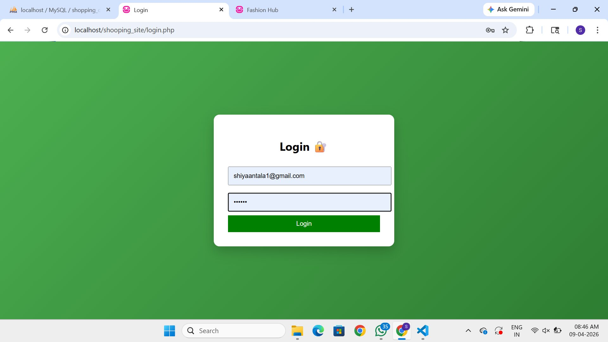
- Login Page (login.php) — The login form is centered on a green background. Users enter their registered email and password, then click the green Login button to authenticate. The lock emoji reinforces security. An incorrect credential displays an error; a successful login starts a PHP session and redirects to index.php.

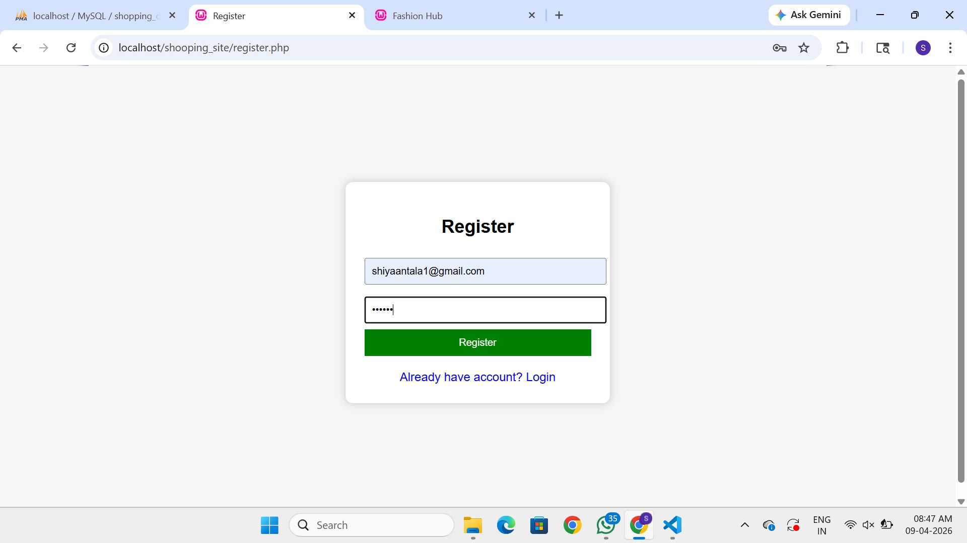
- Registration Page (register.php) — New users provide an email and password to create an account. The 'Already have account? Login' link at the bottom redirects existing users back to login.php. On successful registration, the user is directed to log in.

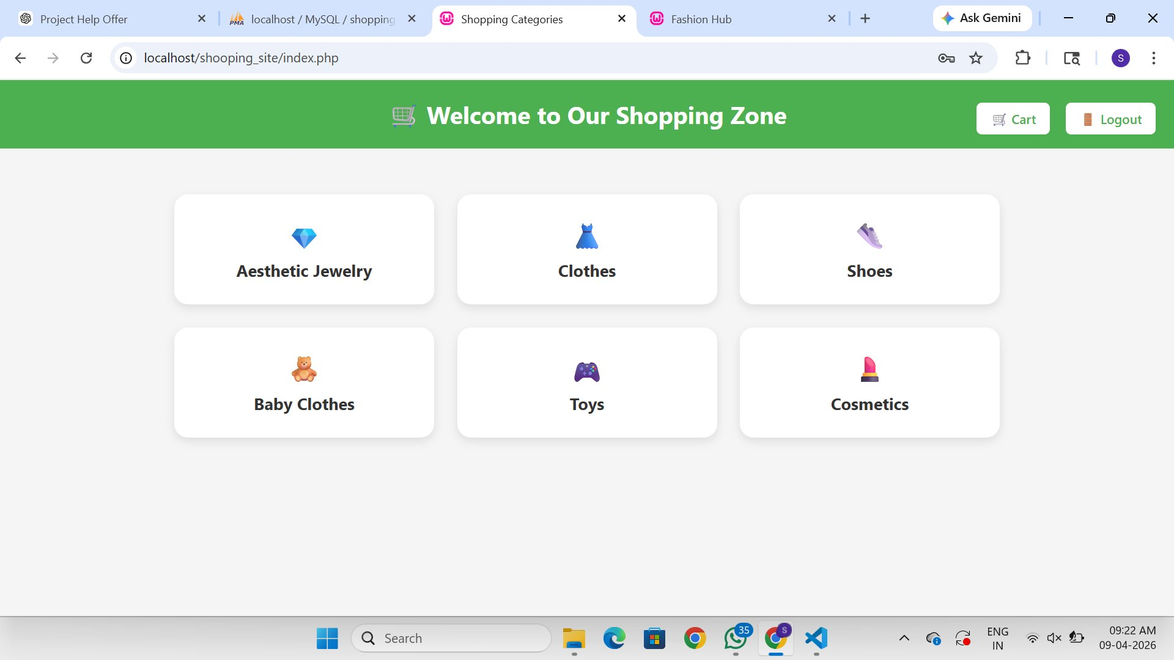
- Shopping Categories Page (index.php) — After login, users see six category cards: Aesthetic Jewelry 💎, Clothes 👗, Shoes 👟, Baby Clothes 🧸, Toys 🎮, and Cosmetics 💄. Cart and Logout buttons appear in the top-right of the green navigation bar. Each card navigates to the corresponding product list.

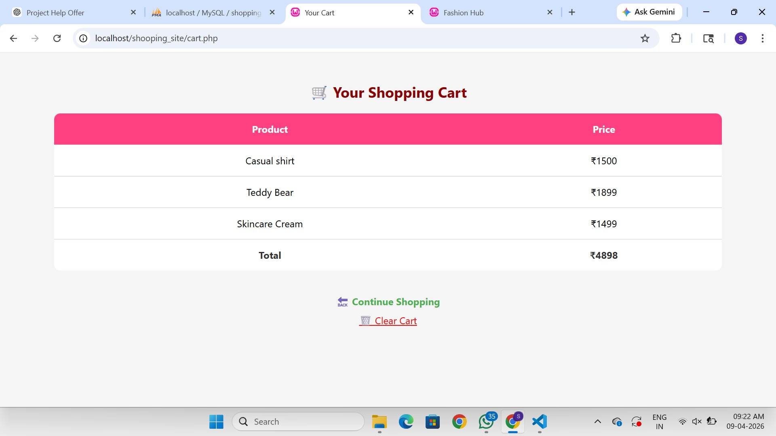
- Shopping Cart Page (cart.php) — Displays all items added to the session cart with their individual prices in INR. A 'Total' row at the bottom sums all prices. The hot-pink header row (Product | Price) provides clear visual contrast. 'Continue Shopping' returns users to categories; 'Clear Cart' empties the session cart.

4. CONCLUSION
- The Shopping Zone web application successfully demonstrates a complete, self-contained PHP and MySQL e-commerce flow. User authentication via hashed passwords and PHP sessions provides a secure and stateful experience. The category-based browsing interface gives shoppers a structured and intuitive way to discover products across six diverse categories.
- The session-based shopping cart allows users to accumulate items across multiple page navigations and view a consolidated price total, closely mirroring real-world e-commerce behavior. The application can be extended by adding a product database table (replacing hardcoded items), a checkout and payment flow, an admin panel for product management, and user order history tracking.
- Overall, this project illustrates how PHP, MySQL, HTML, and CSS can work together to build a functional, well-structured web shopping application suitable for academic demonstration and further development.

5. LEARNING DURING PROJECT WORK
- PHP Sessions: Implementing $_SESSION to maintain login state and cart data across multiple pages without requiring a database write for every cart action.
- Password Security: Using PHP's password_hash() and password_verify() functions to store and validate credentials securely, avoiding plain-text password storage.
- MySQL Integration: Writing PDO or mysqli queries to insert new users during registration and retrieve/validate users during login, including parameterized queries to prevent SQL injection.
- Responsive Card Layout: Using CSS Flexbox/Grid to create a uniform, aesthetically pleasing 3×2 category card grid that adapts to different screen widths.
- Session-based Cart: Learning to store, retrieve, and clear associative arrays in $_SESSION to replicate a shopping cart without a cart database table.
- UI/UX Consistency: Applying a consistent green brand color across navigation, buttons, and backgrounds, while using contrasting accent colors (hot-pink cart header) to guide user attention.

6. BIBLIOGRAPHY

6.1 Online References
- PHP Documentation — PHP Manual: Session handling, password functions, PDO. https://www.php.net/manual/
- MySQL Documentation — MySQL 8.0 Reference Manual: DDL, DML, user management. https://dev.mysql.com/doc/
- W3Schools — PHP, HTML, CSS Tutorials and References. https://www.w3schools.com/
- Stack Overflow — Community Q&A for PHP/MySQL troubleshooting. https://stackoverflow.com/
- OpenAI. ChatGPT (AI Tool) — Used for guidance, code assistance, and project understanding. https://chat.openai.com/
- Google. Google Search — Used for general research, problem-solving, and technical references. https://www.google.com/

6.2 Offline References
- No offline references were used in the preparation of this project.

FIGURE INDEX
Sr. No. | Figure No. | Particulars | Page No.
1 | Fig. 1 | Login Page — Email and password form on green background
2 | Fig. 2 | Registration Page — New user sign-up form
3 | Fig. 3 | Shopping Categories — 6 product category cards
4 | Fig. 4 | Shopping Cart — Items, prices and total

TABLE INDEX
Sr. No. | Table No. | Particulars | Page No.
1 | Table 1 | Module / file description and responsibility
2 | Table 2 | users table — MySQL field structure
3 | Table 3 | Session cart structure — key/value pairs
4 | Table 4 | Figure Index
5 | Table 5 | Table Index (this table)

